Student Sheet Name_______________________Period:____

Title: Doppler Effect

Introduction: Can you think about what happens to the pitch of the sound of a siren or a racecar as it goes by? That change in pitch is the Doppler Effect. It is important to understand because it relates to all moving objects and can help us understand how we know the universe is expanding from the Big Bang. In this activity, you will see and explore several ways we can understand the Doppler effect.

Procedures:
1. Go to https://phet.colorado.edu/sims/html/wave-on-a-string/latest/wave-on-a-string_en.html. If that’s too long, go to hammerscience.weebly.com > Links > Wave on a String.
The first thing you will want to do is set ‘dampening’ to none, and tension somewhere in the middle. On the top right, switch the setting to ‘no end’

Now click on the wrench and quickly shake it up and down (high frequency). What do you observe about the distance between the peaks of the string?:

Now do it more slowly (low frequency). What do you notice about the distance now?:

Feel free to explore the app a little longer if you want: change dampening or tensions, or even the end type.

2. Now go to https://tinyurl.com/nmbhrar and make sure adobe flash is enabled. Drag the spaceship forward towards the planet and release. Watch the bottom left as the spaceship moves forward. How does the frequency (distance between the peaks of the waves) of the line change as the ship moves towards the planet?

3. What happens to the frequency as soon as the ship passes the planet?

6. Light travels in waves also. When light is effected by movement, we call it red shift or blue shift because it has color. Red has a lower frequency of light and blue is higher.

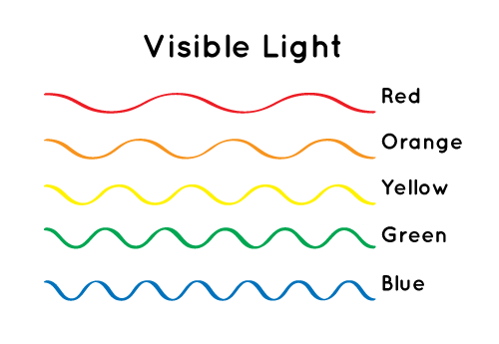
If something is moving away from us, its light spectrum is shifted towards the red end of the spectrum. Fill in the missing labels on this comparison (the waves are not to scale and would be different for light in reality):

Frequency type (low or high)? Frequency type?

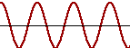
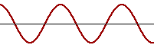

Color? Color?

7. In groups of 4 or 5, use the Internet to research facts and create an 8.5 x 11 poster that advertises a rock and roll group called “The Doppler Effect”. Be creative and make it interesting to look at but also include 5 facts about the Doppler effect. Underline the statements or pictures to show where your facts are.

8. Red Shift refers to how the spectrum of light waves shifts towards the red end when an object is moving away from the observer. Your homework for tonight (due next time we meet) is to read pages 18 and 19 of the textbook (hammerscience > Earth Science > Homework > Textbook) and answer the following questions:

- What is redshift and what does it tell us about the universe?

- In your own words, explain the Doppler Effect and how that explains the direction of an object’s motion.

- How does redshift help support our idea of how the universe began?

