EARTH SCIENCE FINAL REVIEW
You and your table group will research and answer one of the topics below (which I will assign to you). You will then create a poster that presents all your assigned information for the class. When everyone has completed their portion of the review, we will go around and use everyone’s posters to fill in this entire worksheet. This is not all of the material you will need for the SAGE and the final, but it is a good guide to direct your studying.

There are about 15 questions per unit, for a total of 120 questions.
- Intro to universe

- How did the formation of the Universe occur?

- Why is the speed of light significant in supporting the Big Bang Theory?

- Which of the following would be the best model of the “Big Bang” theory?
A. Dropping a bag of oranges off of a tall building
B. Popping a balloon
C. Blowing up a balloon
D. Deflating a balloon

- Why are graphs and charts important?

- What is the difference between a dependent and independent variable?

- What classifies something as a planet?

- What classifies something as a star?

- What kind of objects would you expect to find in a solar system? List and describe at least 5.

- What is a light year?

- What is a galaxy? And what is at the center of almost every galaxy?

- What are the three main types of galaxies, and how can they be identified?

- What makes a protostar different from a star?

- What two forces are in balance in main sequence stars?

- What is the difference between a hypothesis and a theory?

- Fill in the following chart that describes the life cycle for both low and high mass stars:

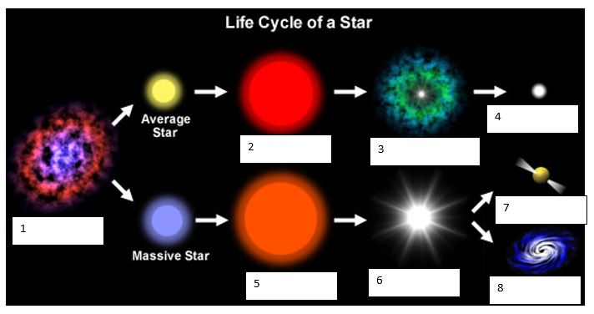

- Our Solar System

- What are the four main regions of our Solar System? Describe the general properties of objects in each region.

- Describe our current hypothesis as to how the Solar System formed.

For questions 3 – 11, describe the general properties (including unique features) of the planets in our Solar System.
- Mercury –

- Venus –

- Earth –

- Mars –

- Jupiter –

- Saturn –

- Uranus –

- Neptune –

- Pluto and other KBOs –

- What is our current theory as to how the Moon formed?

- List a few of Jupiter’s most interesting moons and describe some of their unique features.

- List and describe the function of the four main types of devices humans send to study objects in space.

- List and describe the biggest space programs NASA has had since its foundation.

- Our Earth, Lithosphere basics

- How did Earth form? Where does the majority of Earth’s internal heat come from, and what is keeping it from cooling down?

- Describe the theory of continental drift, including at least three pieces of evidence, and explain how it is different from the theory of plate tectonics.

- List and describe the three main types of plate boundaries:

- List and describe the main layers of Earth, both by composition and by physical properties.

- At what type of plate boundary would you be most likely to find an earthquake?

- At what type of plate boundary would you be most likely to find a CONTINENTAL volcanic arc?

- At what type of plate boundary would you be most likely to find a volcanic ISLAND arc?

- What is the driving force of plate tectonics?

- What happens when a continental plate and an oceanic plate collide?

- What happens when two oceanic plates collide?

- What happens when to continental plates collide?

- List and describe at least three ways we know what the inside of the Earth is made of?

- What are the three main types of volcanoes and how do they differ from each other?

- How fast do plates move?

- What kind of technology has helped us map the ocean floor?

- Rocks and Minerals

- What are the five qualifications to be a mineral?

- For the following materials, say whether or not they are a mineral, and if not which of the qualifications they violate: Rust, Bromine, Coal, Ruby, Plastic, Calcite, Granite, Water, Ice

- What are the two main ways that minerals form? Give an example of a mineral that forms in each way.

- What is the difference between ‘Extrusive’ and ‘Intrusive’?

- What is the difference between a rock and a mineral?

- How are minerals classified? How is this different from how rocks are classified?

- List and describe the three main types of rocks.

- Give two examples each for how physical and chemical weathering occur:

- Which type of weathering dominates in cold regions? Warm regions? Dry regions? Wet regions?

- Draw a DETAILED diagram of the rock cycle, and be sure to include all the paths possible for a rock from birth to present day.

- What is the difference between the focus and epicenter of an Earthquake?

- Intro to hydrosphere/oceans
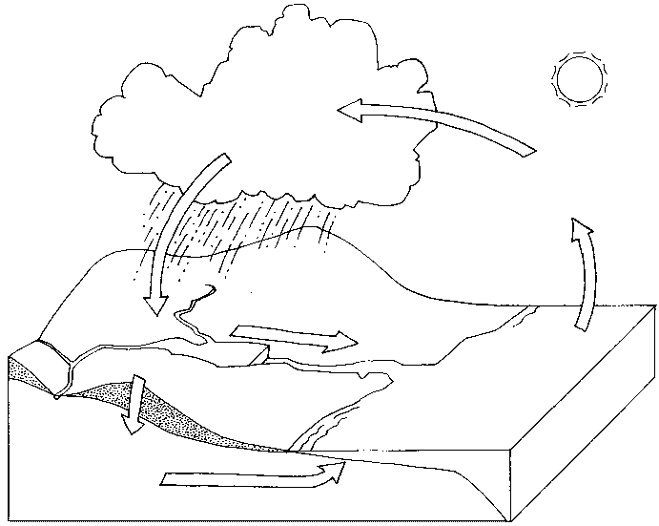
- Label each part of the water cycle, and give a brief description of what is happening at each stage (There should be at least four if not five):

- What is Cohesion? Give an example:

- What is Adhesion? Give an example:

- What does it mean to be polar or non-polar? How do these two interact?

- Describe how Earth got its oceans:

- Where is the majority of water on Earth?

- Where is the majority of fresh water on Earth?

- Where is the majority of surface water on Earth?

- What is heat capacity? Does water have a high or low heat capacity? Dirt?

- What is the difference between an ocean and a sea?

- What is salinity? How does this compare to oceans? Salt lakes?

- How are salt lakes formed?

- List and describe the five main regions of the ocean floor:

- What are the three main groups of life in the ocean? What makes each one unique?

- Where is most sea ice on Earth located?

- What does Archimedes’ Principle state? What does density depend on?

- Fresh water

- Describe how freshwater is used worldwide in terms of percentages.

- What is the difference between a river, stream, and brook?

- What is the largest river in the world? What is the longest river in the world?

- What is a river system? What determines how large rivers become?

- What did most lakes on Earth used to be?

- What is special about the Great Lakes in North America?

- What is unique about swamps?

- What are the two main types of glaciers? How are they alike? How are the different?

- Define the following:
  - Water table:

  - Infiltration:

  - Zone of Aeration:

  - Zone of Saturation:

  - Sinkhole:

- Why do the Great Lakes have fresh water while the Great Salt Lake has salt water?

- Which states currently use the most water?
- What kind of issues are we facing concerning fresh water use in the United States (there are several)?

- List several ways we can conserve water, both at home and at the industrial level.

- What is the difference between point source and non-point source pollution?

- What main types of pollution come from the following?
  - Agriculture:

  - Construction:

  - Landfills:

  - Surface mining:

- Intro to atmosphere / climate

- What is the difference between a revolution and a rotation?

- Explain why we have seasons on Earth? Do we have seasons on other planets?

- What did Earth’s first atmosphere look like? How is that different from what it’s like today? What happened to make it change?

- What affect to volcanic eruptions have on temperature?

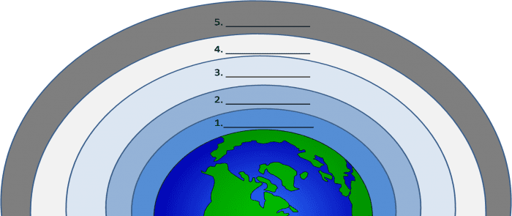
- List and describe the five main layers of the atmosphere (including properties or any special features):

- List and describe the four main things that can happen to light when it hits the atmosphere.

- What are other forms of light besides visible light (List at least three)? Which forms of light does the atmosphere block?

- What is the difference between Mie, Rayleigh, and Non-selective scattering?

- What can happen to Solar Energy if it reaches the surface of the Earth?

- What is a feedback loop?

- What is the difference between a positive and a negative feedback loop? Give an example of each in nature.

- What is the difference between climate and weather?
- What factors determine the climate of a place?

- Describe the Coriolis effect:

- What is wind? Why does it happen? In which direction does wind typically travel?

- Weather systems

- What are the three ingredients necessary for cloud formation?

- What is dew point and what two things does it depend on?

- Describe the two different ways we classify clouds and give examples for each.

- Explain what causes high pressure systems to form on Earth?

- Explain what causes low pressure systems to form on Earth?

- What is an air mass? What are the four types of air masses?

- What is a front?

- Where do we find Earth’s major tropical rainforests? Why are they located in this region?

- Where do we find Earth’s major deserts? Why are they located in these regions?

- What is relative humidity? How is it calculated?

- Describe the four main types of fronts and what happens at each.

- List the main types of tools we use to measure weather and describe what each does.

- What are the ingredients for a tornado? How do they form?

- What are the ingredients for a hurricane? How do they form?

- How does lightning form?

