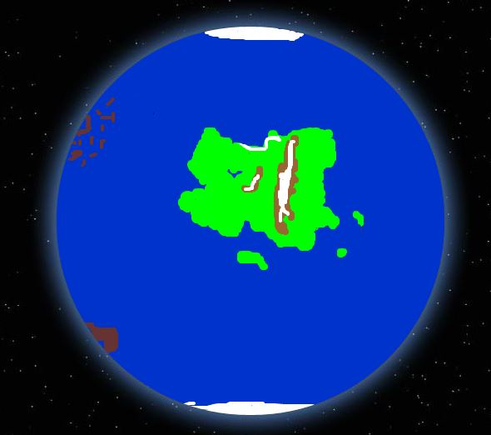  Planet Name: Pomona | Planetary Order: Fourth from its star
 | Planetary Size: 1.07 times the diameter of Earth.
Rotation Time (Earth Days):
1.053 days (25 hours, 17 minutes)
Orbit Time (Earth Years):
1.145 years
396.9 Pomonan days (417.94 Earth days)
 | Gravity: 1.12 times Earth’s gravity
Number of Moons: 2, Pathos and Logos
Origin of Planet Name: Named after the goddess of fruit and abundance. Chosen because the planet is rich in a variety of plants and fruit bearing trees.

Mean Temperature: 53 degrees Fahrenheit. Temperature varies based on latitude, however it is regulated well due to the large ocean that covers much of the surface of the planet.
Description of Surface:
There are three continents, however most of the surface is covered in ocean. The main continent has the largest variety of climates and ecosystems, with cold mountains in the interior of the continent, and hot, dry deserts in the south. One large mountain chain divides the main continent into two; the west side is temperate for the most part while the east is very warm and very moist. One of the other continents is mainly comprised of a series of new volcanoes and a wide, shallow inland sea. The third continent is small and barren, only about a sixth of the size of the main continent.

Cool Facts:
Pomona is rich with life, at least on the main continent. There is a large variety of plants and fruit bearing trees which support many diverse ecosystems. There are liquid water oceans covering most of the planet which in turn support life on the continents. Much like Earth, Pomona has water cycles, with rain, snow, lakes, rivers, etc. Every Fall Pomona also experiences a heavy rain season, with occasional severe storms hitting the main continent.

Life?: Yes, in abundance.
Human Habitable?: Yes, on the main continent. The smallest continent is too barren, and the second continent is rich in poisonous fumes however.

