Name ___________________________________ | Date ________ | Period _____________
Exploring Subducting Plate Boundaries

Directions: On your data table you will find information on earthquakes near the west coast of South America. Provided are the latitude, longitude, depth and magnitude (how strong the earthquake was) of each earthquake.
Your research will require you to take the data provided on earthquakes, plot the data on a graph, and determine what type of pattern (if any) that the earthquakes show in the region.
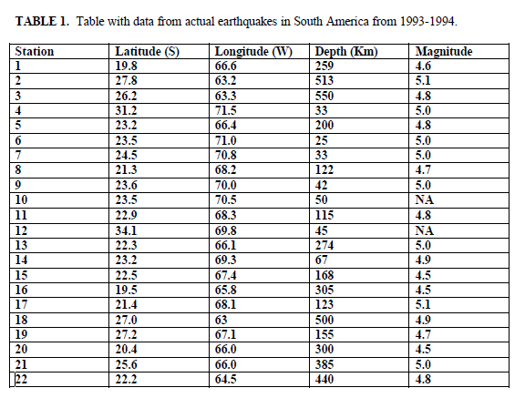

Looking at the Results:
Please answer the following questions:
- What information does an epicenter provide about an earthquake?

- What is the difference between the focus and the epicenter of an earthquake?

- What do you notice about the depth of the focus of the earthquakes as you go further inland from the coast of South America?
- What appears to be happening to the two plates that meet along the west coast of South America, according to your model?

- Draw and label a diagram or make a model showing what is happening to the plates along the west coast of South America as you described in question 4:

Making Conclusions:
6. Describe the type of plate boundary which you think is present along the west coast of South
America.

7. Explain how your data supports your conclusions in question 6.

8. How can our model explain the deep trench that lies just off the coast of South America?

9. Look at a map of plate boundaries and plate movement. Where are some other areas where this same type of plate boundary is occurring?

Going Further
10. How is volcanism related to this type of boundary (study where it is in relation to the trench and plates)? (Explain in words and with a drawing.)

